17. Letter Combinations of a Phone Number
Medium

Given a string containing digits from 2-9 inclusive, return all possible letter combinations that the number could represent. Return the answer in any order.
A mapping of digits to letters (just like on the telephone buttons) is given below. Note that 1 does not map to any letters.
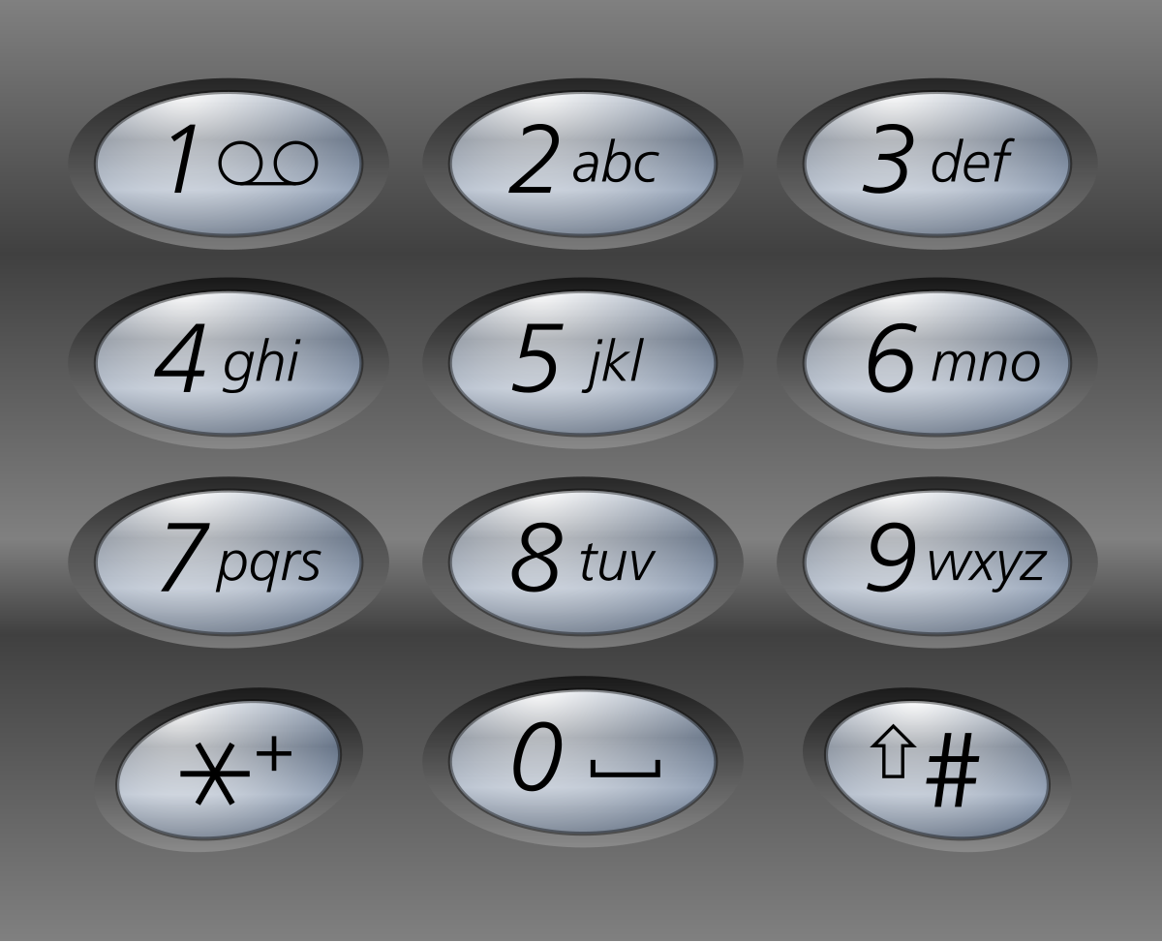

Example 1:
Input: digits = "23"
Output: ["ad","ae","af","bd","be","bf","cd","ce","cf"]
Example 2:
Input: digits = ""
Output: []
Example 3:
Input: digits = "2"
Output: ["a","b","c"]

